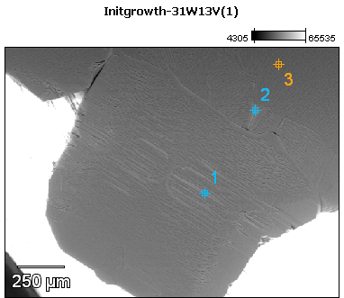

Image Name: Initgrowth-31W13V(1)

Image Resolution: 512 by 384

Image Pixel Size: 3.54 µm

Acc. Voltage: 13.0 kV

Magnification: 70

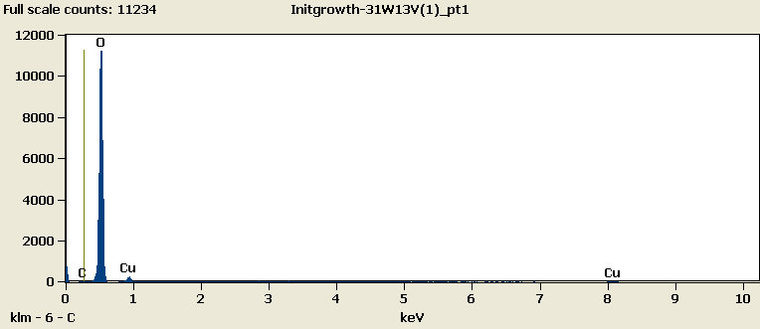

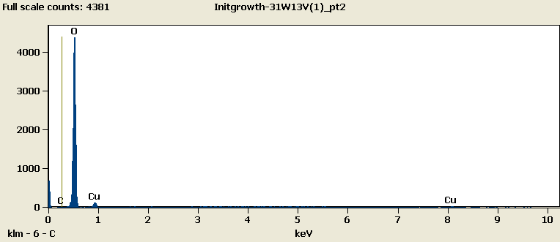

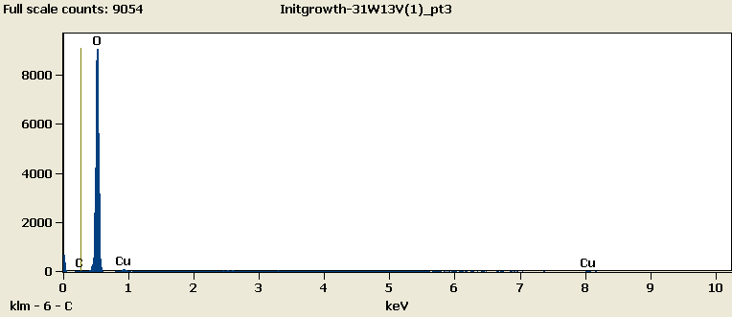

Weight %

|  |  |  |  |
| --- | --- | --- | --- |
|  | ***C-K*** | ***O-K*** | ***Cu-L*** |
| ***Initgrowth-31W13V(1)_pt1*** | 0.00 | 87.63 | 12.37 |
| ***Initgrowth-31W13V(1)_pt2*** | 0.00 | 85.82 | 14.18 |
| ***Initgrowth-31W13V(1)_pt3*** | 0.00 | 91.62 | 8.38 |

Weight % Error (+/- 1 Sigma)

|  |  |  |  |
| --- | --- | --- | --- |
|  | ***C-K*** | ***O-K*** | ***Cu-L*** |
| ***Initgrowth-31W13V(1)_pt1*** | ±0.00 | ±0.35 | ±0.36 |
| ***Initgrowth-31W13V(1)_pt2*** | ±0.00 | ±0.47 | ±0.43 |
| ***Initgrowth-31W13V(1)_pt3*** | ±0.00 | ±0.39 | ±0.37 |

# Cations

|  |  |  |  |
| --- | --- | --- | --- |
|  | ***C-K*** | ***O-K*** | ***Cu-L*** |
| ***Initgrowth-31W13V(1)_pt1*** | 0.00 | 0.00 | 0.00 |
| ***Initgrowth-31W13V(1)_pt2*** | 0.00 | 0.00 | 0.00 |
| ***Initgrowth-31W13V(1)_pt3*** | 0.00 | 0.00 | 0.00 |